Olist Brazilian E-Commerce
Business Intelligence Report

2016 – 2018 | Exploratory Data Analysis

Prepared by: Data Science Team
Dataset: Olist Public E-Commerce Dataset (Kaggle)

Executive Summary
This report presents a comprehensive analysis of the Olist Brazilian e-commerce marketplace covering approximately 100,000 orders placed between 2016 and 2018. The analysis is structured around four pillars: Business Growth, Customer Experience, Seller & Operational Performance, and Customer Geography. Key findings and strategic recommendations are summarized below.

Total Orders Analyzed | 99,441 | Sep 2016 – Oct 2018
Total Product Revenue | R$13.6M | Excl. freight
Total Payments (incl. freight) | R$16.0M | Incl. installments
Platform Avg Review Score | 4.09 / 5 | All delivered orders
Late Delivery Rate | 7.9% | Platform-wide
Repeat Customer Rate | 3.12% | Based on unique customer ID
Top 10% Sellers Revenue Share | 67.6% | ~310 sellers

Key Findings
• Order volume grew rapidly through 2017, peaking at 7,544 orders in November 2017 (Black Friday), before stabilizing at 6,000–7,000/month in 2018.
• Average order value was remarkably stable at R$137–163 throughout the period, confirming growth was driven by volume, not price inflation.
• Late delivery is the single strongest driver of customer dissatisfaction: on-time orders average 4.29 stars vs. 2.57 stars for late orders — a 1.72-point gap.
• A severe geographic disparity exists: customers in northern states wait 3x longer (29 days vs. 9 days in SP) and pay 2–3x more for freight than southeastern customers.
• Revenue is highly seller-concentrated: the top 10% of ~3,100 sellers generate 67.6% of all revenue.
• Only 3.12% of customers made repeat purchases, indicating the platform is heavily dependent on customer acquisition rather than retention.

Pillar 1: Business Growth

1.1 Order Volume Trends
Order volume grew consistently from late 2016 through mid-2017, with a pronounced spike in November 2017 coinciding with Brazil's Black Friday shopping event (7,544 orders). Following the spike, volume stabilized in the 6,000–7,000 orders/month range through 2018. The low counts observed at the very start (Sep–Oct 2016) and end (Sep–Oct 2018) of the dataset are attributable to data truncation rather than real business decline.
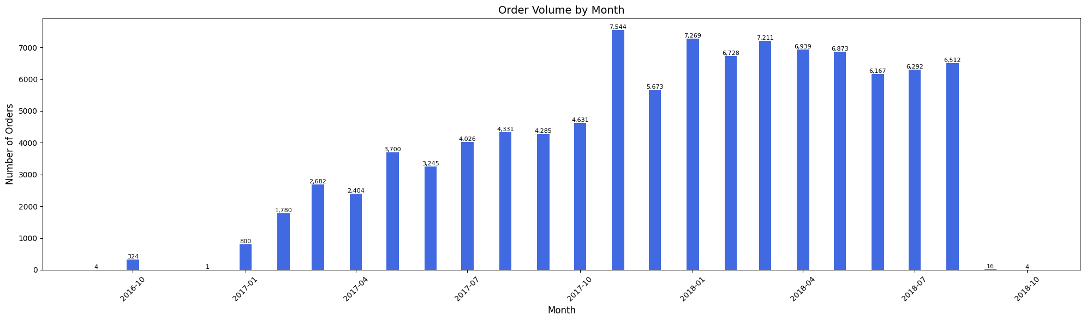
Figure 1: Monthly order volume, Sep 2016 – Oct 2018

1.2 Revenue Trends
Total product revenue tracked order volume closely, peaking at R$1.19M in November 2017 and settling in the R$1.0–1.16M/month range through 2018. The tight correlation between volume and revenue confirmed that average order value (AOV) was the stabilizing factor — not pricing shifts or category mix changes.
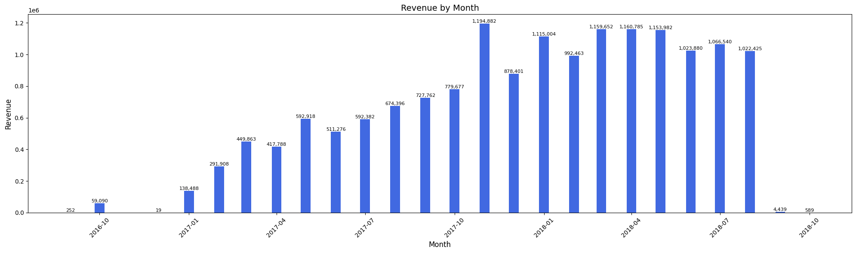
Figure 2: Monthly product revenue, Sep 2016 – Oct 2018

1.3 Average Order Value
AOV remained flat in the R$137–163 range for virtually the entire dataset period. The apparent spike in September 2018 is a statistical artifact caused by very low order counts (fewer than 20 orders) in that month. This stability indicates a mature and consistent pricing environment with no significant product mix drift over time.
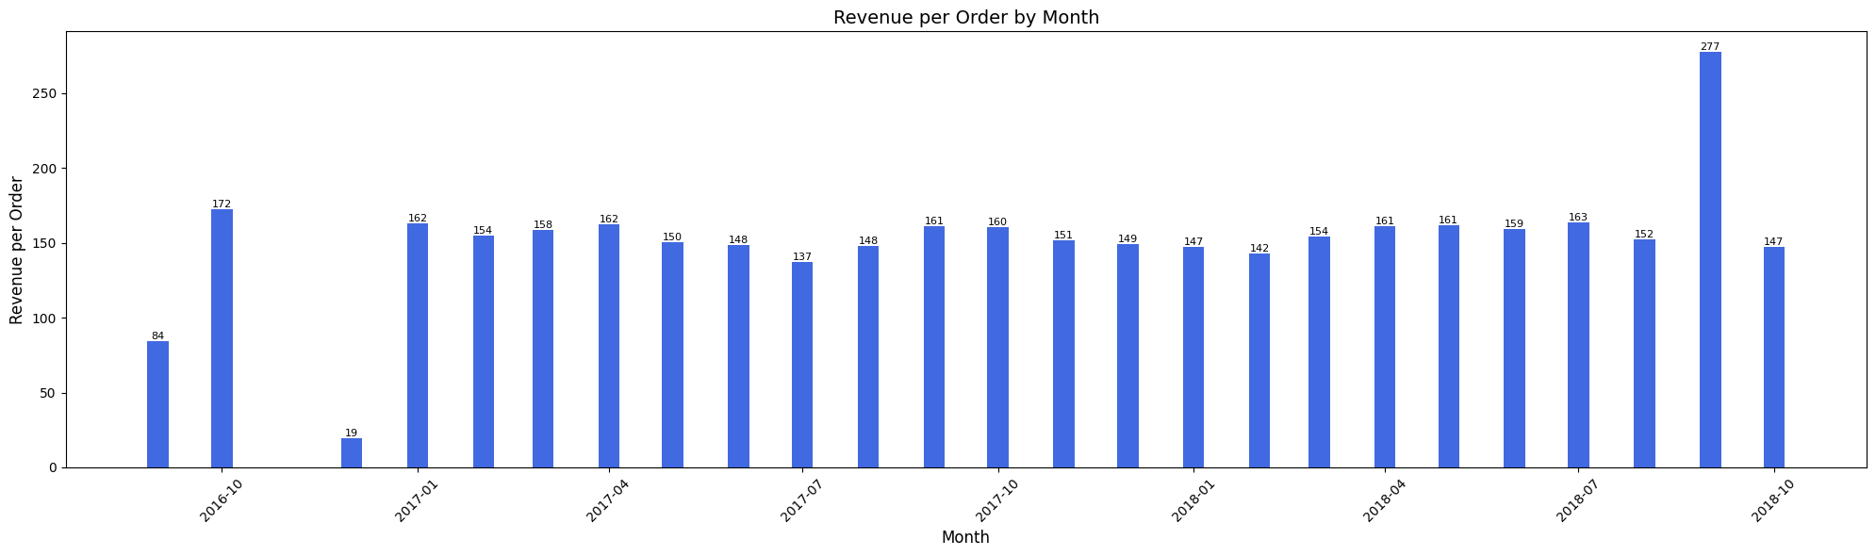
Figure 3: Average order value (revenue per order) by month

1.4 Top Product Categories by Revenue
The top 10 product categories account for approximately 63% of total product revenue, indicating a moderately concentrated but not overly top-heavy revenue base. Health & beauty and watches & gifts lead at 9% each, followed by bed, bath & table at 8%. Notably, the top categories span diverse segments — personal care, home goods, electronics, and accessories — reflecting broad marketplace appeal rather than niche specialization.
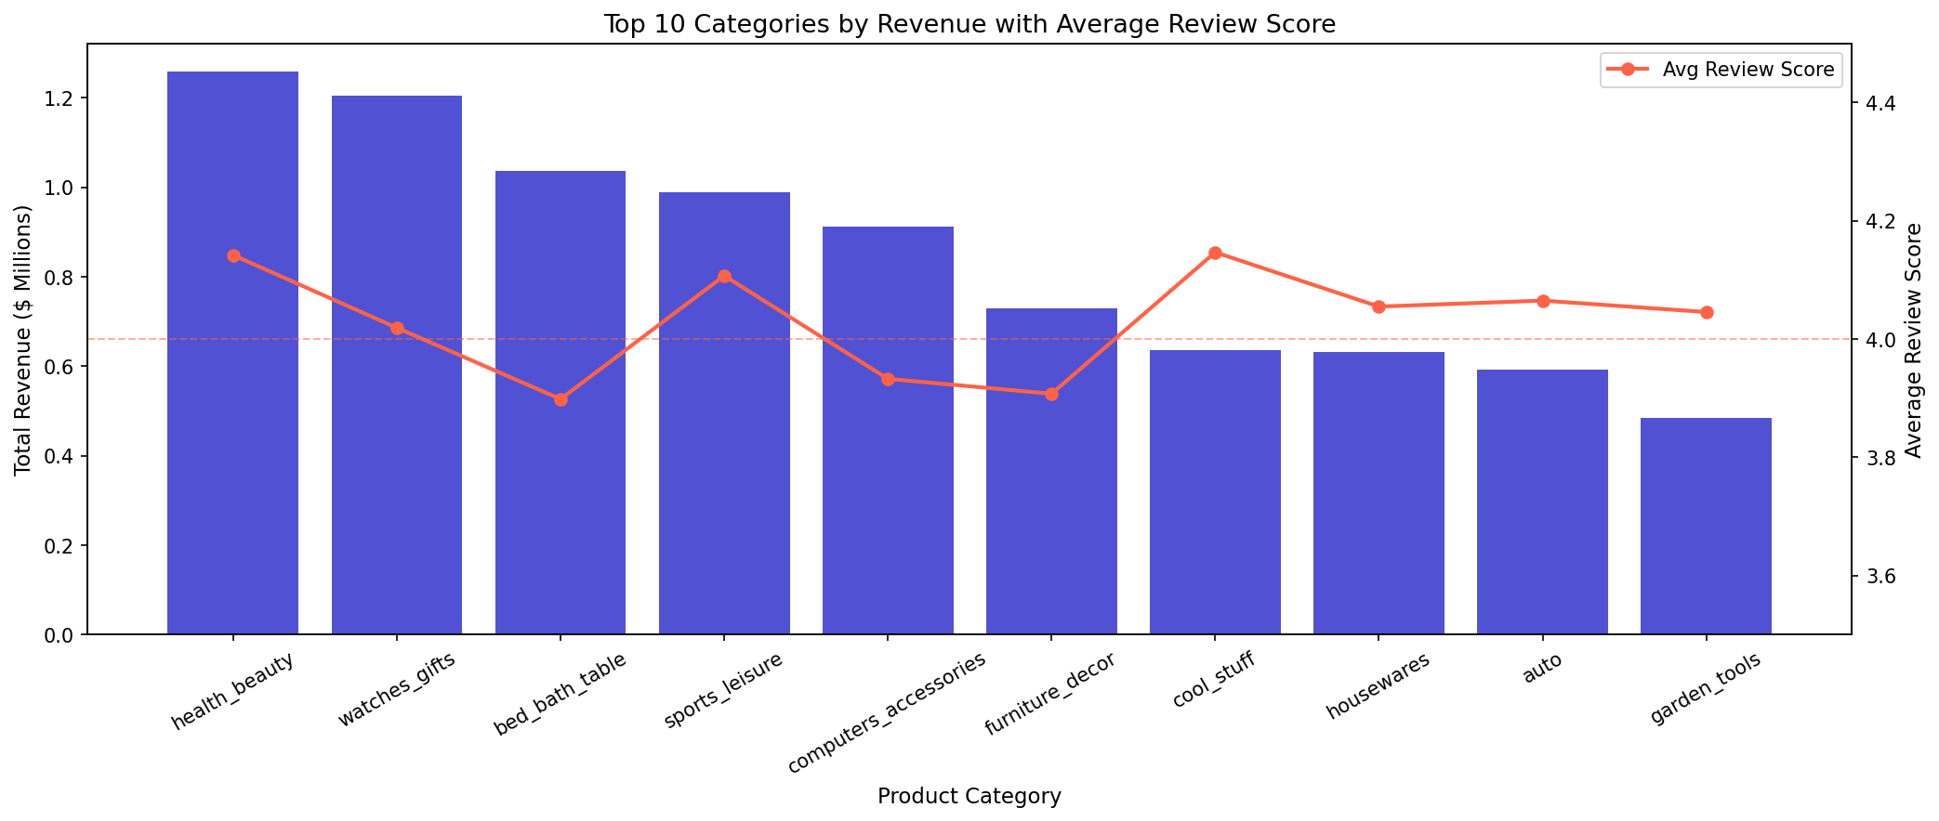
Figure 4: Top 10 categories by revenue with average review score overlay

Pillar 2: Customer Experience

2.1 Review Score Distribution
Overall platform sentiment is positive: 58% of orders received a 5-star review and 19% received 4 stars, for a combined satisfaction rate of 77%. However, 1-star reviews are notably prevalent at 12% of all orders — making it the third most common rating. This polarized distribution suggests a binary experience: when things go well, customers are delighted; when they go wrong, the reaction is severe.
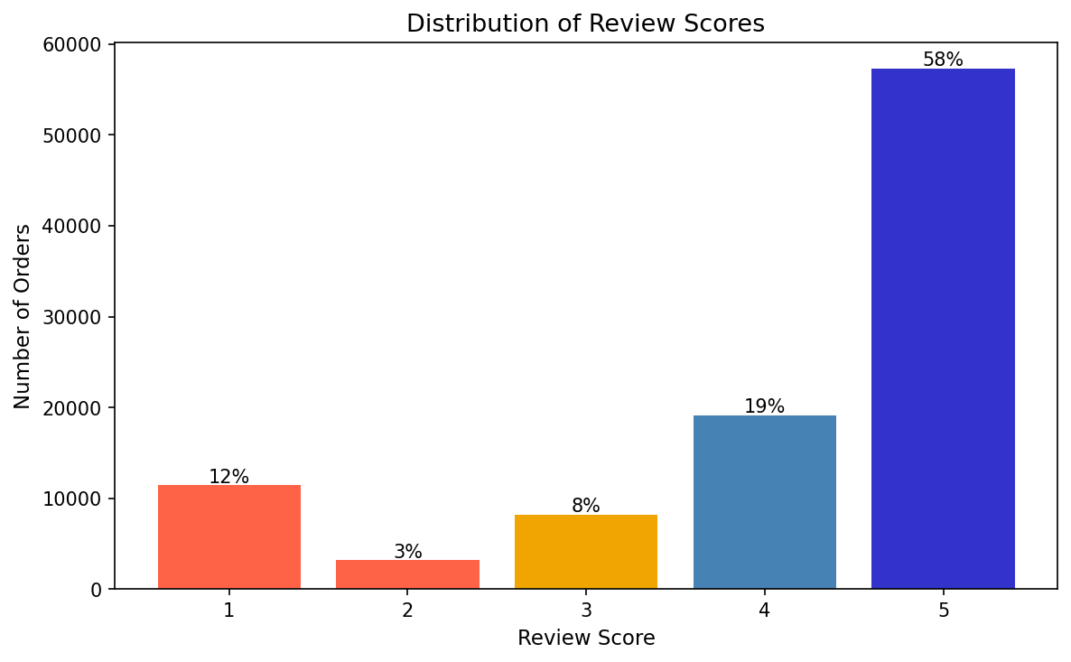
Figure 5: Distribution of review scores across all orders

2.2 Impact of Delivery Timing on Satisfaction
Delivery timing is the single most powerful driver of customer satisfaction identified in this analysis. Orders delivered on time averaged 4.29 stars across 89,139 orders, while late orders averaged just 2.57 stars across 7,866 orders — a statistically significant gap of 1.72 points on a 5-point scale.
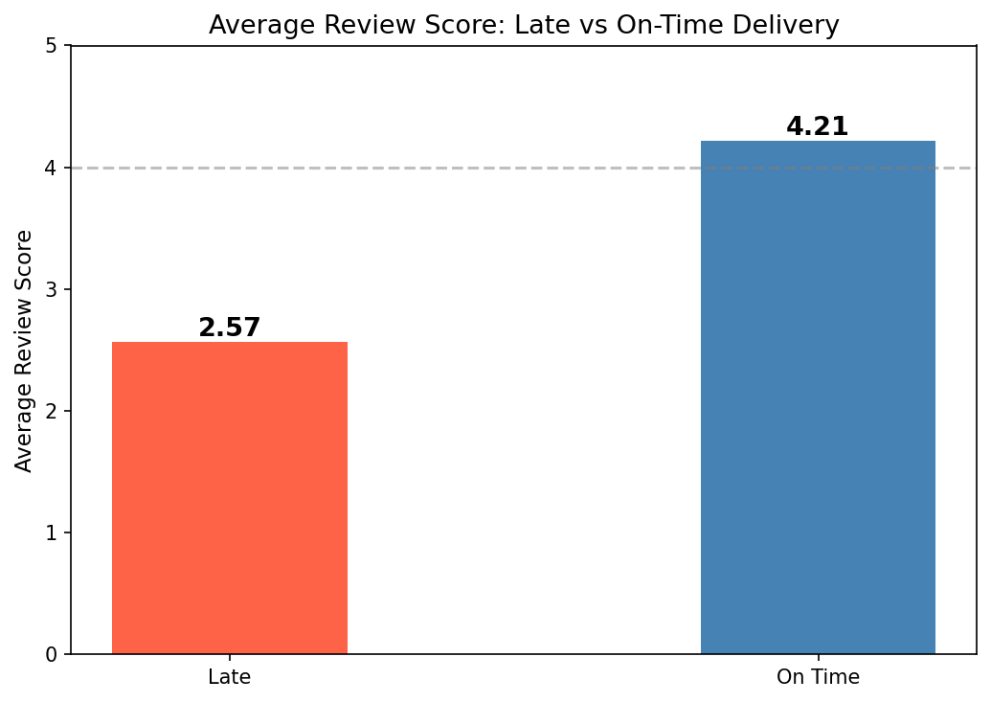
Figure 6: Average review score by delivery status
This finding reframes all category-level satisfaction analysis. The three revenue categories with sub-4.0 review scores — bed_bath_table (3.90), computers_accessories (3.93), and furniture_decor (3.91) — have late delivery rates of 8.3–8.4% vs. a platform average of 7.9%. While the difference seems marginal, given how severely late delivery suppresses scores, even small increases in late rates meaningfully drag down category averages. These categories also tend to involve larger, bulkier items that are inherently harder to fulfill on time.

2.3 Payment Behavior
Credit card is the dominant payment method, accounting for 73% of all orders (76,795 orders). Boleto — a Brazilian cash payment slip commonly used by unbanked consumers — represents 19% of orders (19,784), reflecting the importance of serving Brazil's large cash-reliant population. Debit card (1.5%) and voucher (5.5%) round out the mix.
Credit card customers average 3.5 installment payments per order, consistent with Brazil's deeply ingrained parcelamento (installment) culture. This behavior allows customers to purchase higher-value items by spreading payments over multiple months, and likely contributes to the platform's healthy AOV of R$150+.

2.4 Repeat Purchase Rate
Only 3.12% of customers (identified via their unique customer ID) made more than one purchase during the dataset period, with repeat buyers averaging just 2.12 orders. This extremely low retention rate reveals that Olist's growth during 2016–2018 was almost entirely acquisition-driven. While this is not unusual for a marketplace in a high-growth phase, it represents a significant strategic vulnerability: the business is heavily dependent on a continuous inflow of new customers rather than compounding value from existing ones.
One-time customers | 96.88% | Of all unique customers
Repeat customers | 3.12% | Purchased more than once
Avg orders (repeat buyers) | 2.12 | Among repeat customers only

Pillar 3: Seller & Operational Performance

3.1 Seller Revenue Concentration
Revenue generation is highly concentrated among a small number of sellers. The top 10% of sellers — approximately 310 out of ~3,100 — account for 67.6% of total product revenue. This classic power-law distribution has significant implications for platform risk management: the loss or churn of even a small number of top sellers could materially impact revenue. These relationships warrant dedicated account management and retention programs.
Total active sellers | ~3,100 | With at least one order
Top 10% seller count | ~310 | Revenue threshold: ~R$9,550+
Revenue from top 10% | 67.6% | Of total product revenue

3.2 Seller Geographic Concentration
The seller base is overwhelmingly concentrated in Brazil's South and Southeast regions. São Paulo state alone accounts for 59.7% of all sellers, and the top 5 states (SP, PR, MG, SC, RJ) collectively represent ~90% of the seller base.
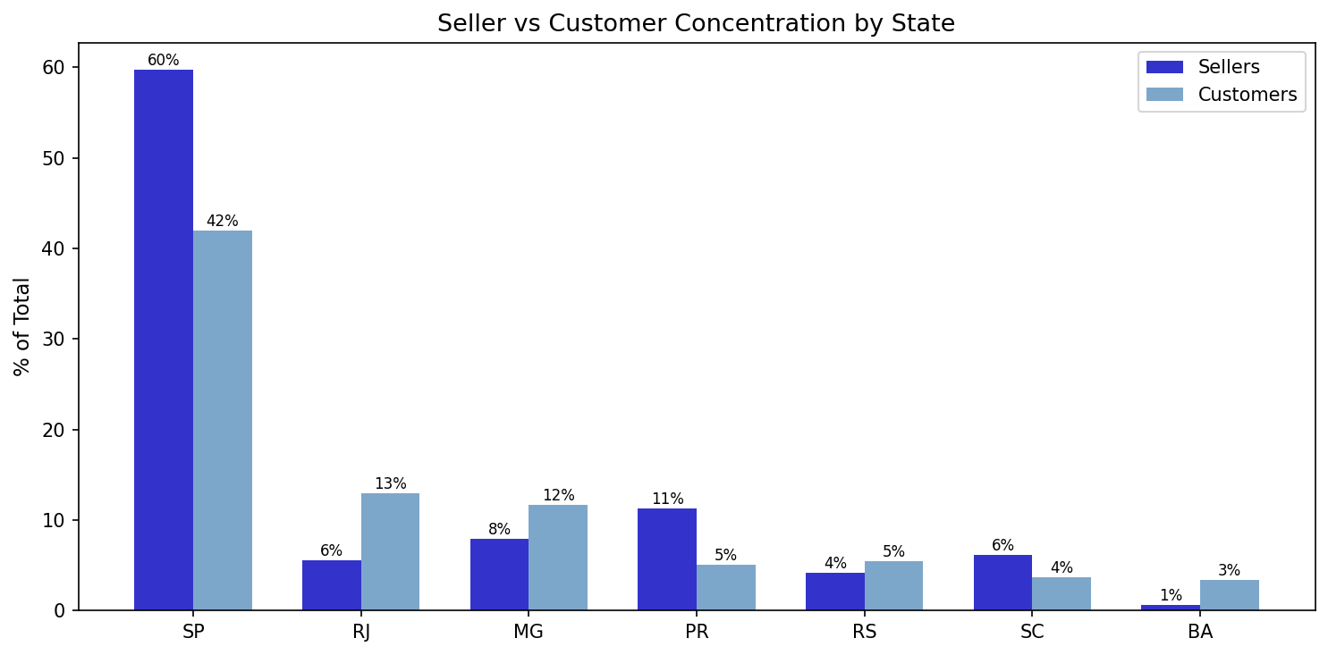
Figure 7: Seller vs. customer share by state — geographic mismatch

3.3 Seller Growth Over Time
New seller onboarding was consistent throughout the dataset period, averaging 100–200 new sellers per month. A notable spike of 228 new sellers occurred in February 2017, coinciding with the platform's rapid demand growth phase. Crucially, unlike order volume (which plateaued in 2018), seller onboarding remained steady — indicating that supply-side growth continued even as demand growth stabilized. This suggests Olist was deliberately building a robust seller pipeline rather than reactively chasing demand.
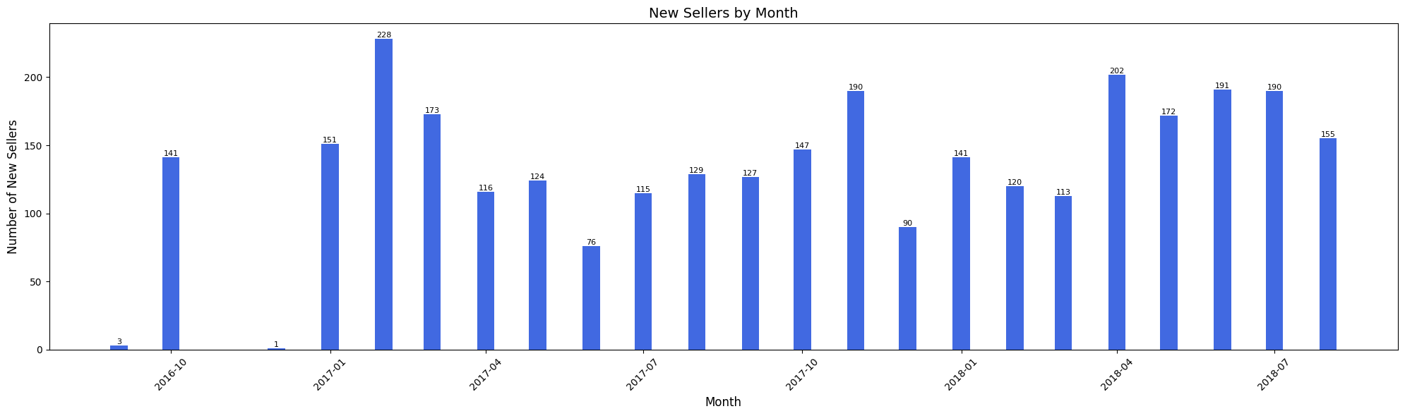
Figure 8: New sellers joining the platform by month

Pillar 4: Customer Geography

4.1 Revenue by Customer State
Customer revenue mirrors Brazil's economic geography closely. São Paulo dominates at R$5.2M (38% of total revenue), followed by Rio de Janeiro (R$1.8M, 13%) and Minas Gerais (R$1.6M, 12%). Together, these three southeastern states account for approximately 63% of all customer revenue — a significant concentration in the wealthiest region of Brazil.

4.2 The Geographic Disparity: Delivery, Freight & Satisfaction
The most consequential geographic finding in this analysis is the compounding disadvantage faced by customers in Brazil's North and Northeast regions. These customers experience significantly longer delivery times, higher freight costs, and — as a direct consequence — lower satisfaction scores than their southeastern counterparts.
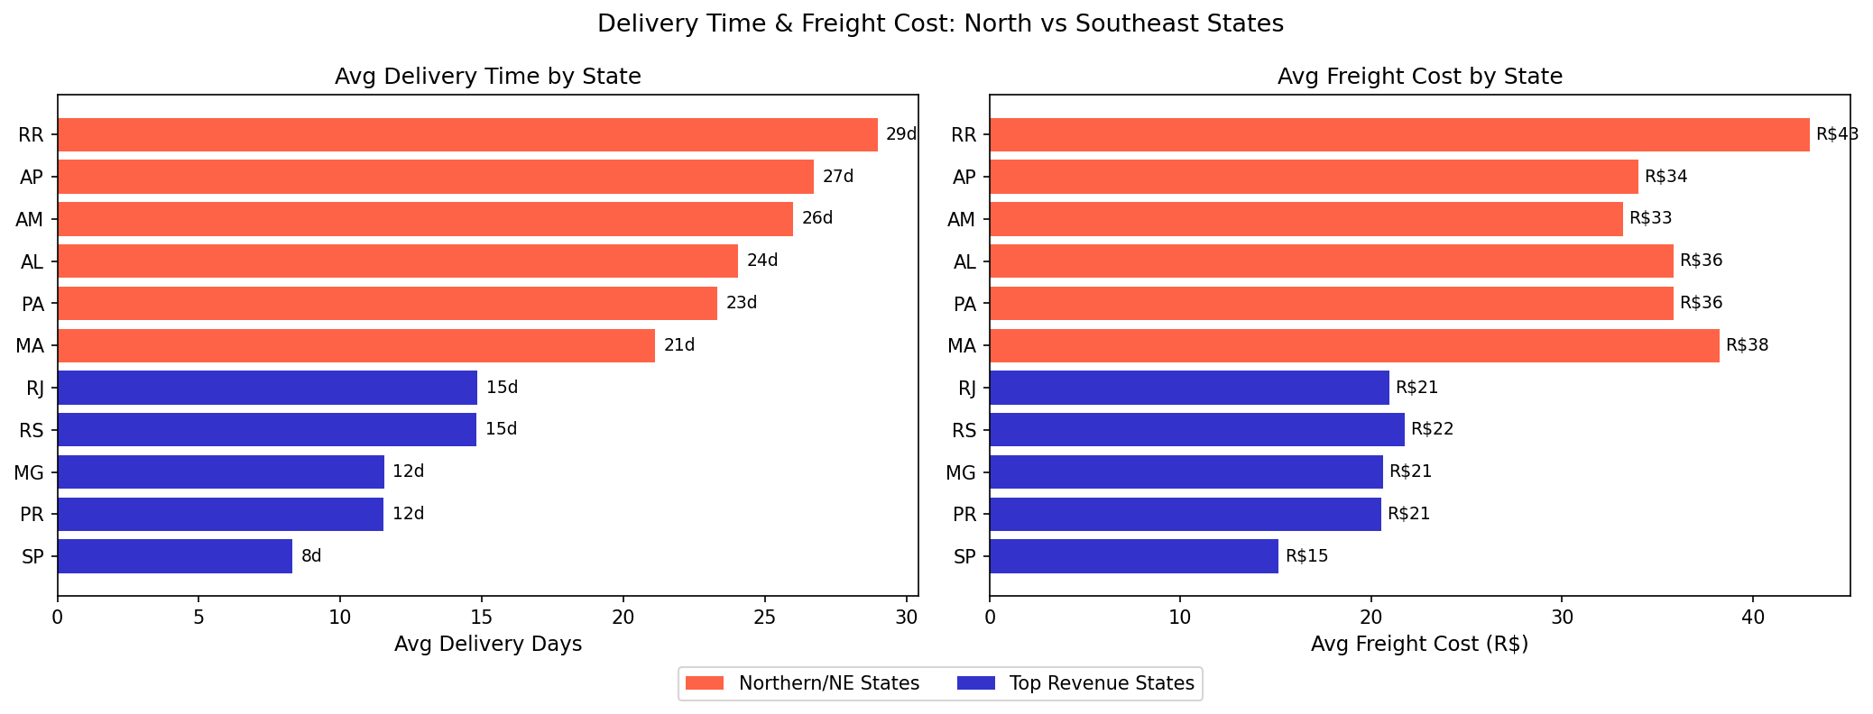
Figure 9: Average delivery time and freight cost — northern vs. southeastern states

SP avg delivery time | ~9 days | Fastest in dataset
RR avg delivery time | ~29 days | Slowest — 3.2× longer than SP
SP avg freight cost | ~R$15 | Lowest in dataset
RR avg freight cost | ~R$43 | Nearly 3× higher than SP
RR avg review score | 3.61 | Lowest in dataset
SP avg review score | ~4.1 | Among highest in dataset

This data tells a coherent story: the geographic concentration of sellers in São Paulo means that customers in remote northern states — Roraima (RR), Amapá (AP), Amazonas (AM), Alagoas (AL), Pará (PA) — are being served from great distances. The result is delivery times approaching a month, freight costs double or triple the national average, and review scores well below the platform mean.

4.3 Seller-Customer Geographic Mismatch
A critical structural imbalance exists between where sellers are concentrated and where customers are located. While SP accounts for 59.7% of sellers, it represents only 42% of customers. Conversely, Rio de Janeiro (12.9% of customers, ~2% of sellers) and Minas Gerais (11.7% of customers, 7.9% of sellers) are significantly underserved on the supply side relative to their customer demand. This mismatch is the root cause of the geographic disparity in delivery performance documented above.

Strategic Recommendations

1. Prioritize Delivery Reliability as the #1 Customer Experience Lever
The 1.72-point review score gap between on-time and late deliveries is the most impactful finding in this analysis. Reducing the 7.9% late delivery rate should be the platform's top operational priority. Even a 2–3 percentage point improvement in on-time delivery would meaningfully lift average review scores, which in turn could improve repeat purchase rates.

2. Expand Seller Presence in the North and Northeast
The single most effective way to simultaneously reduce delivery times, lower freight costs, and improve satisfaction scores in underserved regions is to grow the seller base in those regions. Targeted seller recruitment campaigns in states like RR, AP, AM, AL, MA, and PA would reduce the distance goods must travel and directly address the root cause of the geographic disparity. Warehouse or fulfillment partnerships in these regions could serve as an interim solution.

3. Build a Retention Program Around the Top Seller Cohort
With 67.6% of revenue concentrated in just ~310 sellers, the platform faces meaningful concentration risk. A formal key account management program — including dedicated support, performance analytics, and incentive structures — would protect this revenue base and deepen platform stickiness among the highest-value sellers.

4. Invest in Customer Retention to Reduce Acquisition Dependency
A 3.12% repeat purchase rate is a significant strategic vulnerability for a marketplace at this stage of growth. Initiatives such as loyalty programs, post-purchase re-engagement campaigns, personalized recommendations, and installment-friendly promotions could materially improve retention. Given that credit card users already average 3.5 installments per order, there is clear appetite for structured payment options that could also encourage return purchases.

5. Develop Category-Specific Quality Programs for Sub-4.0 Categories
Bed, bath & table, computers & accessories, and furniture & decor all score below 4.0 and have slightly elevated late delivery rates. Beyond delivery improvements, product quality standards, better listing accuracy (to manage expectations), and improved packaging for bulky/fragile items should be explored in partnership with sellers in these categories.

Appendix: Dataset Overview
This analysis is based on the Olist Brazilian E-Commerce Public Dataset, sourced from Kaggle. The dataset covers approximately 100,000 orders placed between September 2016 and October 2018 across multiple Brazilian online marketplaces. All personally identifiable information has been anonymized, and references to stores and partners in review text have been replaced with fictional names.

Orders | 99,441 rows | Core order lifecycle data
Order Items | 112,650 rows | Line-item pricing and freight
Customers | 99,441 rows | Geographic information
Sellers | 3,095 rows | Seller location data
Payments | 103,886 rows | Payment type and installments
Reviews | 99,224 rows | Satisfaction scores and comments
Products | 32,951 rows | Category and physical attributes
Category Translations | 71 rows | Portuguese to English mapping

